
MBARARA UNIVERSITY OF SCIENCE AND TECHNOLOGY
P.O BOX 1410 MBARARA-UGANDA
FACULTY OF COMPUTING AND INFORMATICS
Department of Computer Science
PROGRAM: BACHELOR OF SCIENCE IN COMPUTER SCIENCE
NAME:TALEMWA APUULI DAVID
REG NO.: 2025/BCS/176/PS
COURSE: DATABASE SYSTEMS
LECTURER: MR.KENNETH BAGUMA
DATE: 24TH MARCH 2026
ASSIGNMENT : DATABASE SYSTEMS PROJECT REPORT

Executive Summary
This document provides a comprehensive technical overview of the Staff and Lecturer Management System. It serves as the primary reference manual for developers, database administrators, and system architects. The report details the system architecture, backend database schema, essential SQL queries, middleware API structures, and frontend user interface design

BUSINESS CASE

a. Application domain
The Staff and Lecturer Management System (SLMS) operates in the higher education, TVET and large‑school environments, where institutions must manage a growing number of academic and non‑academic staff across multiple departments and campuses. It addresses the full lifecycle of staff data and lecturer workload management from hiring and onboarding to workload allocation, performance evaluation and contract renewal.

Supported tasks, operations and processes
1. Staff information management
The system provides a centralized repository for all staff‑related data. Typical operations include:
● Creating and updating staff profiles with personal details (name, contact information, ID/passport, emergency contacts).
● Recording employment details such as position, department, grade, contract type (permanent, fixed‑term, part‑time), start and end dates and probation status.
● Recording education and professional qualifications (degrees, certifications, specialization areas) to support academic quality assurance.
● Storing digital copies of important documents (CVs, employment contracts, certificates, performance appraisal forms) in an organized manner.
2. Lecturer workload and teaching management
In most institutions, allocating lecturers to courses and ensuring fair workload distribution is complex and often handled manually:
● Assigning lecturers to courses/modules and to specific class groups or time blocks.
● Calculating teaching load for each lecturer based on contact hours, number of courses, student groups and other academic duties (supervision, tutorials).
● Monitoring overload and underload, comparing actual loads with institutional policies or contract agreements.
● Generating teaching allocation sheets and workload summaries that can be shared with Heads of Department (HODs) and lecturers.
3. HR operations, attendance and compliance
The system supports routine HR tasks as well as regulatory requirements:
● Managing leave applications: staff can submit requests online, supervisors approve or decline and HR can monitor balances and histories.
● Tracking attendance where applicable (for example, support staff or hourly paid lecturers), potentially integrating with biometric or clock‑in devices in future versions.
● Recording performance review cycles, including setting review periods, storing scores, comments and agreed development plans.
● Supporting compliance with accreditation bodies by providing accurate staff statistics (student‑to‑staff ratios, qualification levels, full‑time vs part‑time distribution).
4. Reporting, analytics and decision support
Decision‑makers require up‑to‑date information, which is difficult to obtain from spreadsheets:
● Standard reports such as staff lists, qualification summaries, staff by department or role and upcoming contract expirations.
● Workload reports showing total teaching hours per lecturer, per department and per program which are used to identify staffing gaps or surpluses.
● HR reports for strategic planning: age distribution, years of service, promotion eligibility and turnover patterns.
● Dashboards that visualize key indicators (e.g., headcount trends, percentage of staff with a minimum qualification, distribution of workloads).

User groups and their needs
● HR staff and administrators need accurate, consistent staff records and tools to manage contracts, leave and performance efficiently.
● Academic managers (HODs, Deans, program coordinators) need visibility into lecturer availability, workload and qualifications to plan timetables and launch new programs responsibly.
● Lecturers and general staff need self‑service access to their information (e.g., to check workload, update certain profile fields, apply for leave or upload documents).
● Senior management (Vice‑Chancellor, Principal, Registrars) need high‑level summaries and analytics to support strategic decisions about staffing, program expansion and budgeting.
● IT staff need a system that can be maintained, backed up and integrated with existing platforms (student systems, payroll, LMS) without excessive complexity.
We are assuming that before implementing SLMS, the institution relies heavily on manual spreadsheets and emails, resulting in duplicated data, inconsistent records and slow reporting, a clear justification for building the system.

b. Analysis of benefits

Tangible (quantifiable) benefits
1. Reduced administrative workload and labour costs
● Many HR and departmental tasks (e.g., updating staff lists, running workload reports, tracking leave) currently require manual consolidation of multiple spreadsheets.
● With SLMS, these tasks are automated or significantly streamlined, freeing staff time.
● For example, if three HR officers each save 1 hour per working day because of automation, that is roughly 60 hours per month (assuming 20 working days), which can be valued in monetary terms using their average hourly cost. Over a year, this saving alone can cover a significant portion of system costs.
2. Lower error rates and financial leakage
● Manual processes often lead to mistakes (e.g., wrong salary category, missing contract end dates, incorrect leave balances).
● Such errors can cause overpayments, underpayments or compliance penalties.
● Centralizing data with validation rules (mandatory fields, valid ranges for dates, consistent contract types) reduces these errors, thereby decreasing financial losses and the time spent fixing them.
3. Faster reporting and improved agility
● The time to produce complex reports for audits or management meetings can be reduced from days to minutes.
● This means the institution can respond more quickly to regulatory requests, accreditation visits and internal planning deadlines.
● Faster access to data supports rapid decisions on whether to hire new staff, redistribute workloads or delay certain programs.
4. More efficient staffing and resource utilization
● By seeing a full picture of each lecturer’s workload, management can avoid unnecessary recruitment when existing staff can absorb additional teaching within policy limits.
● Conversely, under‑loaded staff can be redeployed or given additional responsibilities.
● These efficiencies translate into more optimal use of salary budgets and reduced reliance on costly last‑minute hires.

Intangible (non‑quantifiable) benefits
1. Higher data quality and managerial confidence
● When leaders trust the data they see, they are more willing to make decisive changes (e.g., restructuring departments, launching new programs).
● Reliable data reduces internal disputes about “whose spreadsheet is correct” and allows discussions to focus on strategy rather than data correctness.
2. Improved staff satisfaction and engagement
● Self‑service features reduce the need to visit HR for basic queries which can be frustrating and time‑consuming.
● Transparent workload management supports perceptions of fairness between lecturers which can improve morale and reduce conflict.
● Clear records of performance discussions and development plans can also support a culture of continuous improvement.
3. Enhanced compliance and institutional reputation
● Accurate staff records are crucial for accreditation bodies, especially when they verify that lecturers are adequately qualified for the courses they teach.
● A system that can quickly produce evidence tables and statistics strengthens the institution’s reputation as professionally managed and accountable.
4. Strategic alignment and digital transformation
● Introducing SLMS aligns with broader institutional goals of modernization and digital transformation.
● The system can become a foundation for more advanced initiatives like predictive staffing analytics, integration with e‑learning platforms and self‑service portals for external stakeholders.

c. Analysis of costs

Tangible costs
1. System development or purchase
● If developed in‑house then costs include developer time, project management, testing, and documentation.
● If purchased then licensing fees for the software plus any customization or implementation services required.
● In both cases, initial investment is concentrated in the first one or two months.
2. Infrastructure and technical resources
● On‑premise deployment requires servers, network infrastructure, operating systems and backups, plus IT staff time.
● Cloud or hosted deployment requires continuous payment for compute, storage, backup and bandwidth.
● Additional software costs (e.g., database licenses) may apply depending on technology choices.
3. Training and roll‑out
● Time spent by staff attending training sessions (opportunity cost).
● Possible cost of trainers or external consultants to support change management.
● Development of user manuals, help files and support materials.
4. Ongoing maintenance and support
● Bug fixes, updates to handle new requirements or policy changes and system upgrades.
● IT staff allocation or external support contracts for monitoring, backup verification and security patching.

Intangible costs
1. Change management and resistance
● Even a beneficial system can be viewed negatively if users are not well prepared.
● Resistance may manifest as low usage, attempts to continue using old spreadsheets, or reluctance to update data regularly.
● Productivity may initially decrease as users learn new workflows.
2. Learning curve and adoption friction
● Users might find the system complex at first especially if they were used to very flexible spreadsheets.
● If the interface is not intuitive then frustration can rise, affecting morale and acceptance.
3. Organizational restructuring effects
● The system may expose inefficiencies or require process changes (e.g., formalizing who approves leave, standardizing workload rules), and not everyone may welcome such changes.
● This can lead to conflicts over new roles and responsibilities.

Cost–benefit view
When comparing costs and benefits, it is important to consider a multi‑year horizon (e.g., 3–5 years). Initial costs are usually high, but once the system is stable:
● Annual savings in staff time, reduced errors and better use of lecturer resources accumulate.
● The strategic value of better compliance and reputation is difficult to quantify but can easily outweigh the initial investment if for example it helps the institution retain accreditation or attract more students.

d. User issues

1.User skill requirements
● HR users need to be comfortable with data entry forms, search, filters and report generation. They also need to understand how their data feeds into other modules like workload and analytics.
● Academic managers must be able to interpret workload and staffing reports and perform basic operations such as assigning courses, generating teaching lists and validating allocations.
● Lecturers/staff should handle basic self‑service tasks such as viewing their profile, updating allowed fields (e.g., contact details), applying for leave and viewing workload or evaluation summaries.
● IT staff should be skilled in system administration, backups, user account management and basic troubleshooting.
1. Adoption and behavior change
● Some staff will have to change from informal methods (emails, verbal agreements, personal spreadsheets) to standardized workflows enforced by the system.
● Adoption can be increased by explaining how the system simplifies their work, involving them in configuration decisions (e.g report formats) and demonstrating quick wins (e.g fast generation of a report that used to take days).
2. Training approach
● Short, role‑specific training sessions (e.g., “SLMS for HR,” “SLMS for HODs,” “Self‑service for staff”) are more effective than long, generic sessions.
● Hands‑on exercises using real or sample data help users build confidence.
● Training should be treated as an ongoing process, not a one‑off event; new employees must be trained and refresher training should be available.
3. Usability and user support
● A clear navigation structure, consistent terminology and helpful error messages reduce cognitive load.
● Providing an internal champion or “super user” in each department can facilitate informal support and promote best practices.
● A FAQ or knowledge base for common tasks and problems can further ease adoption.

e. Risk assessment

Technical risks
1. Integration failure or delays
● The institution may plan to integrate the system with existing student information systems, payroll or LMS. If these integrations are more complex than anticipated, the system may not deliver full promised value early on.
● Mitigation: Start with a minimal set of integrations, use standard formats and APIs and design the system with loose coupling in mind.
2. Security breaches or data loss
● Staff data is sensitive and includes personal information, salary data and performance evaluations. A breach could have serious legal and reputational consequences.
● Mitigation. Implement strong authentication, role‑based access control, encryption, secure development practices, regular penetration testing and frequent backups.
3. Performance and scalability issues
● As the number of users and records grows (multiple campuses, thousands of staff, historical data), poorly designed queries or infrastructure can cause slow response times.
● Mitigation: Optimize database design and indexing, monitor performance and plan for scalable infrastructure (e.g., vertical/horizontal scaling in a cloud environment).

Organizational risks
1. Lack of sustained management support
● If senior management does not consistently support and enforce the use of the system, departments may revert to old habits.
● Mitigation. Obtain formal sponsorship, include system usage in performance expectations and use reports from the system in official meetings to reinforce its centrality.
2. Poor data migration
● Incomplete, inaccurate or inconsistent data imported from legacy tools can undermine trust in the system from day one.
● Mitigation. Allocate sufficient time and resources to data cleansing; perform test migrations; involve experienced staff who understand the meaning of legacy fields.
3. Misalignment with processes
● If the system is implemented without understanding real workflows, users may feel it forces unnatural procedures or creates extra work.
● Mitigation: Conduct process analysis, involve users in designing workflows and adjust either processes or system configuration based on feedback.

Other risks
1. Scope creep and over‑complexity
● Including too many features in the first release increases project risk and delay.
● Mitigation: Define and protect a realistic Minimum Viable Product (MVP) and plan further enhancements in later phases.
2. Dependence on specific individuals
● If only one developer or one IT staff member fully understands the system, their departure poses a risk.
● Mitigation: Maintain proper documentation, shared code repositories and cross‑training.

f. Limitations of the system

1.Functional scope limitations
● The initial system may not cover all HR functions such as full payroll processing, recruitment portals, or advanced performance management frameworks. Institutions may need to continue using separate systems or manual processes for some specialized tasks.
● Over time, some of these functions can be added, but the system is not a complete replacement for every possible HR or academic management tool.
1. Dependence on data quality and user discipline
● The SLMS can only be as accurate as the data entered into it. If staff delay updates, omit important fields, or circumvent the system, its outputs will suffer.
● Data governance (clear roles and responsibilities, regular audits and user training) remains necessary.
2. Customization and policy variability
● Different institutions have different workload formulas, leave policies, grading standards, and approval hierarchies. It is impossible to build a system that perfectly matches every unique rule out of the box.
● While configuration options can cater for common variations, extremely specific institutional rules may require custom development or compromise.
3. Technological and access constraints
● The system assumes reliable network connectivity and availability of devices for intended users. In environments with frequent power outages or limited connectivity, adoption may be difficult.
● Mobile access may be limited in early versions which can inconvenience staff who rely on smartphones.
4. Analytics and advanced features maturity
● In early phases, the system will mainly provide descriptive statistics. More advanced analytics ( predicting staff shortages, modeling the impact of new programs) require time, data and analytical expertise to develop.
● Users expecting “instant AI” may be disappointed if expectations are not managed.
5. Vendor/solution lock‑in (for SaaS or proprietary implementations)
● If the system is provided as a service by a vendor, institutions may worry about long‑term dependence, pricing changes or difficulties in migrating data to another solution.
● Even with data export options, there will always be some switching cost and potential data loss of derived information (e.g., custom reports, workflows).

DESIGN: LOGICAL DESIGN AND PHYSICAL DESIGN

Logical Design

a. List of Entities
- Department
- Staff
- EmploymentContract
- LeaveRequest
- Qualification
- Course
- TeachingAssignment

b. List of Entities and Attributes
- Department:
DepartmentId (PK), DepartmentName, Location, HeadId (FK), Tel, Faculty
- Staff:
StaffId (PK), Title, FirstName, LastName, Email, Tel, DateOfBirth, HireDate, Position, DepartmentId (FK)
- EmploymentContract:
ContractId (PK), StaffId (FK), Department, ContractType, Duration, HireDate, EndDate, IsRenewable, RenewalStatus, LastRenewalDate, ExitDate, SalaryScale, ActualSalary, Allowances, NSSF_Employee, NSSF_Employer, Gratuity_Accrued, PAYE
- LeaveRequest:
LeaveId (PK), LeaveType, StartDate, EndDate, Status, StaffId (FK)
- Qualification:
QualificationId (PK), DegreeType, Specialization, Institution, YearGraduated, StaffId (FK)
- Course:
CourseCode (PK), CourseName, Credits, DepartmentId (FK), YearOfStudy, Semester
- TeachingAssignment:
AssignmentId (PK), StaffId (FK), CourseCode (FK), Semester, Year, ContactHours

c. Entity Relationships & Multiplicities
- Department to Staff (Employment): A Department employs one or many Staff members (1 : 1..N). A Staff member belongs to zero or one Department (0..1 : 1).
- Staff to Department (Leadership): A Staff member can head zero or one Department (0..1 : 1). A Department has exactly one Head (1 : 1). (This is a binary, 1-to-1 relationship).
- Staff to EmploymentContract: A Staff member can have one or multiple contracts over time (1 : 1..N). A Contract belongs to exactly one Staff member (1 : 1).
- Staff to LeaveRequest: A Staff member can make zero or many leave requests (1 : 0..N).
A LeaveRequest belongs to exactly one Staff member (1 : 1).
- Staff to Qualification: A Staff member can have one or many qualifications (1 : 1..N).
A Qualification belongs to exactly one Staff member (1 : 1).
- Department to Course: A Department offers one or many Courses (1 : 1..N).
A Course is hosted by exactly one Department (1 : 1).
- Staff to Course (Teaching - Many-to-Many): A Staff member teaches zero or many Courses (1 : 0..N). A Course is taught by one or many Staff members (1 : 1..N).
- Staff to TeachingAssignment: (1 : 0..N)
- Course to TeachingAssignment: (1 : 0..N)

e. ER Diagram
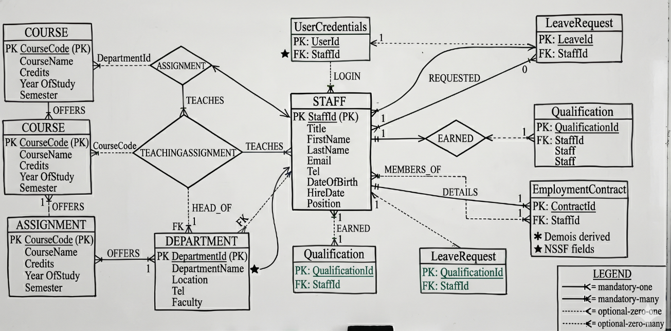

f. User Interface (Dialogue Structure)
The system user interface is structured around Role-Based Access Control (RBAC):
- HR Dashboard :
  - Action: HR Admin selects "Manage Staff".
  - Dialogue: System displays a datagrid of all Staff.
  - Action: Admin clicks "View Contracts".
  - Dialogue: System queries EmploymentContract filtered by StaffId and displays salary, PAYE and NSSF details.
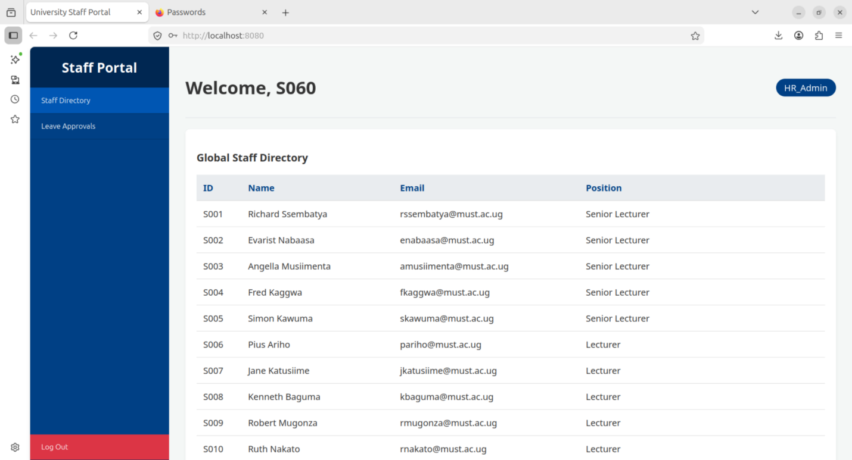
- Academic Registrar Dialogue:
  - Action: Registrar selects "Assign Lecturer".
  - Dialogue: System prompts for CourseCode and StaffId.
  - Action: Registrar inputs details and contact hours.
  - Dialogue: System commits data to TeachingAssignment table and updates the lecturer's workload view.
The Physical Design

g. Database Schema
- Staff.DepartmentId is a Foreign Key referencing Department.DepartmentId.
- Department.HeadId is a Foreign Key referencing Staff.StaffId
- EmploymentContract.StaffId, LeaveRequest.StaffId and Qualification.StaffId are Foreign Keys referencing Staff.StaffId.
- Course.DepartmentId is a Foreign Key referencing Department.DepartmentId.
- TeachingAssignment.StaffId references Staff.StaffId and TeachingAssignment.CourseCode references Course.CourseCode.

h. Description of Queries and Reports
- Output 1: Departmental Payroll Report:
Sums the ActualSalary and Allowances from EmploymentContract grouped by DepartmentId.
  - Allows the Finance Directorate (D011) to monitor departmental budgets and audit NSSF/PAYE compliance.
- Output 2: Academic Workload Matrix:
Joins Staff, TeachingAssignment and Course to calculate the total weekly ContactHours per lecturer.
  - Helps the Academic Affairs Directorate ensure lecturers are not overworked and that all courses have assigned tutors.
- Output 3: Active Leave Register:
Queries LeaveRequest where Status is 'Approved' and current date falls between StartDate and EndDate.
  - Enables HR to quickly see who is currently away from the university (e.g., on Sabbatical or Sick leave) to arrange temporary cover.
Implementation
Query 1 : Showing Tables in database
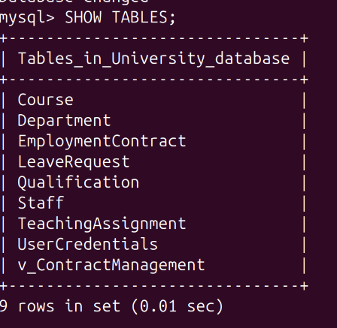
Query 2: Describing the Course Entity
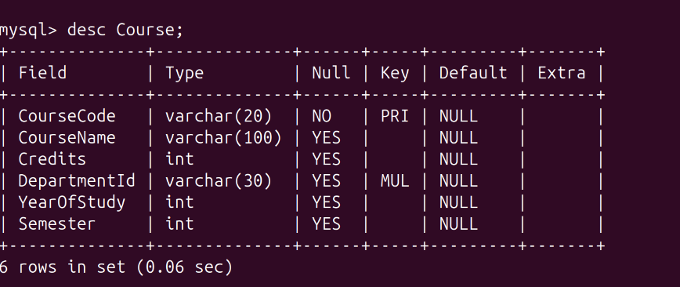

Query 3: Selecting from the Course Table
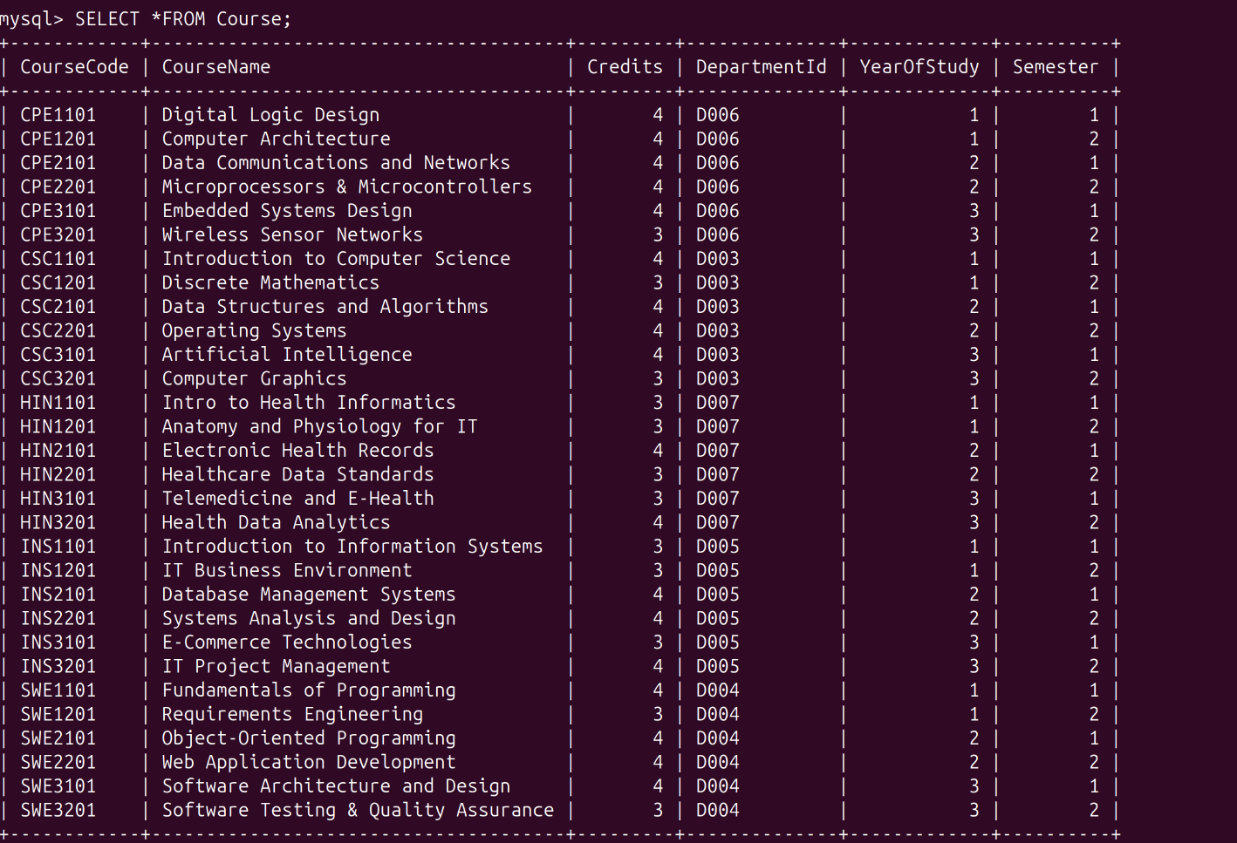

Query 4: Selecting from the Qualification Table
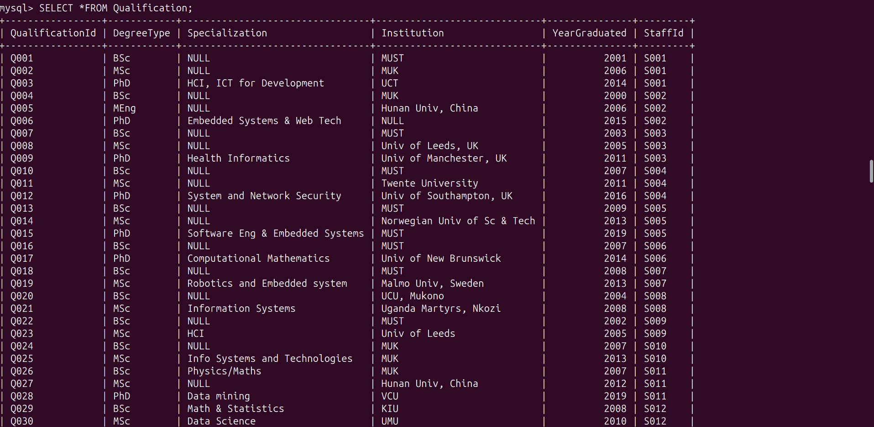

Query 5: See the names of the Heads of each Department. Here, we join the Department table to the Staff table using the HeadId
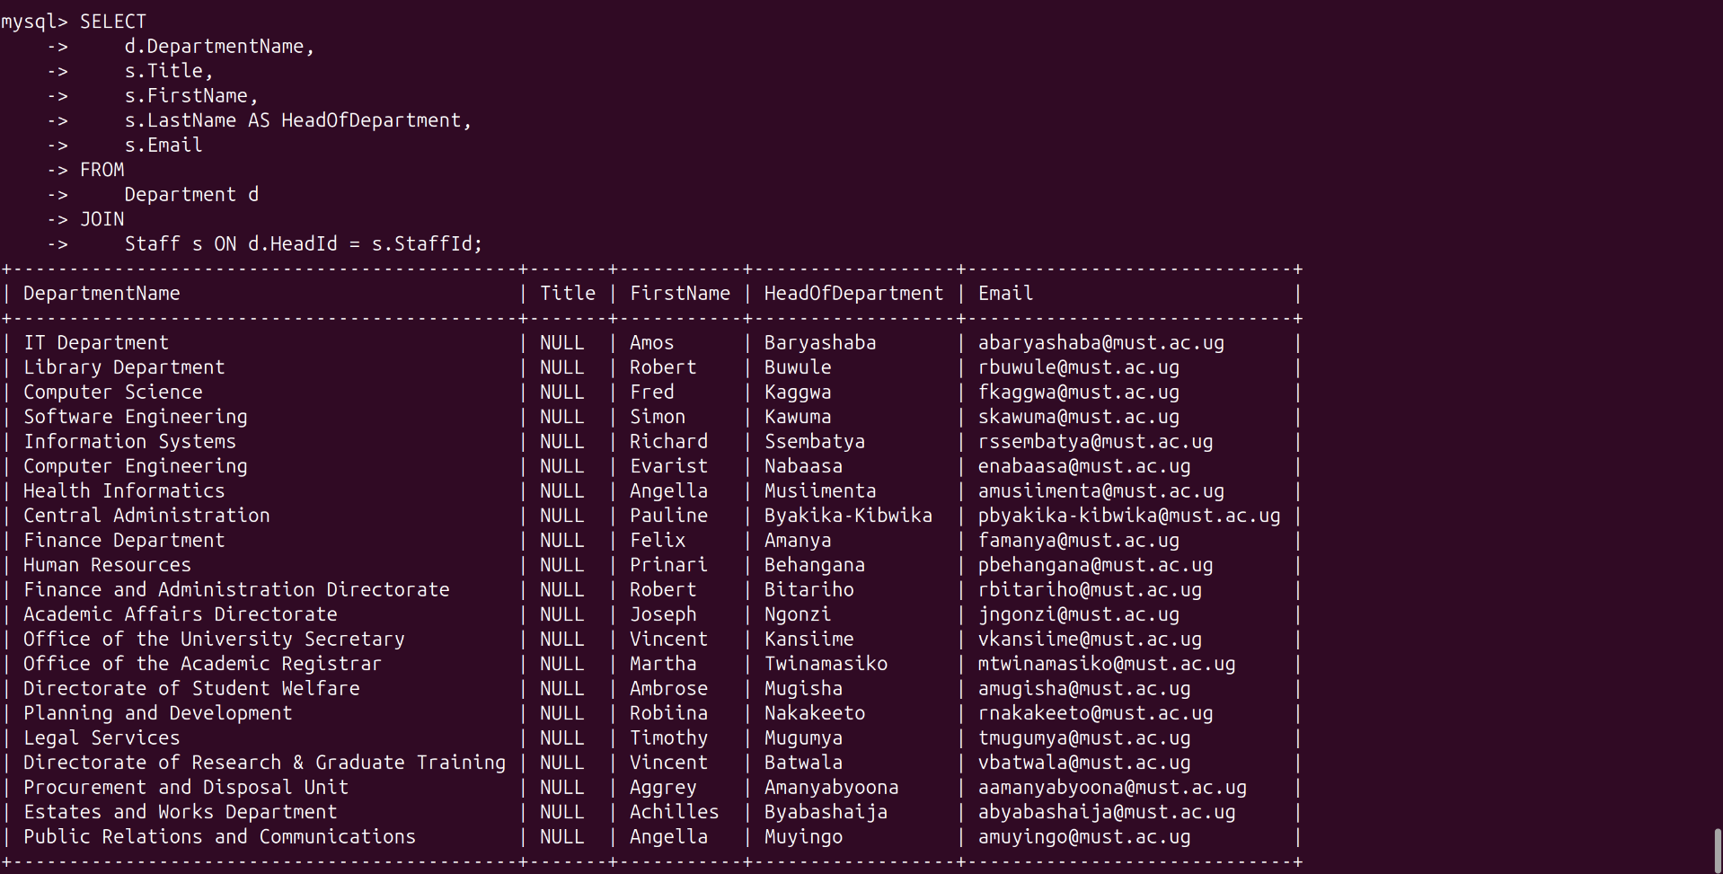

References
Connolly, T., & Begg, C. (2014). Database Systems: A Practical Approach to Design, Implementation, and Management (6th ed.). Pearson. (Reference for the database development lifecycle, normalization (1NF to 3NF), and ER modeling techniques used in the logical design).
Dennis, A., Wixom, B. H., & Roth, R. M. (2021). Systems Analysis and Design (8th ed.). Wiley. (Reference for the Three-Tier Architecture model and translating business requirements into system dialogue structures and user interfaces).
Elmasri, R., & Navathe, S. B. (2015). Fundamentals of Database Systems (7th ed.). Pearson. (Reference for relational algebra, establishing primary/foreign key constraints, and defining mapping multiplicities—1:1, 1:N, M:N).
Kavanagh, M. J., & Johnson, R. D. (Eds.). (2020). Human Resource Information Systems: Basics, Applications, and Future Directions (5th ed.). SAGE Publications. (Reference for the business logic and standard data structures required for tracking employment contracts, payroll, and leave management).
Oracle Corporation. (2026). MySQL 8.0 Reference Manual. Oracle. Retrieved from https://dev.mysql.com/doc/refman/8.0/en/ (Primary technical documentation for SQL syntax, data definition language (DDL), virtual generated columns, and query optimization).

